3

MATT SANDBANK’S SHADOW FACTORY

Study Guide:
The Legend of Walter Weirdbeard:
“Arrrr!” Is for Reading

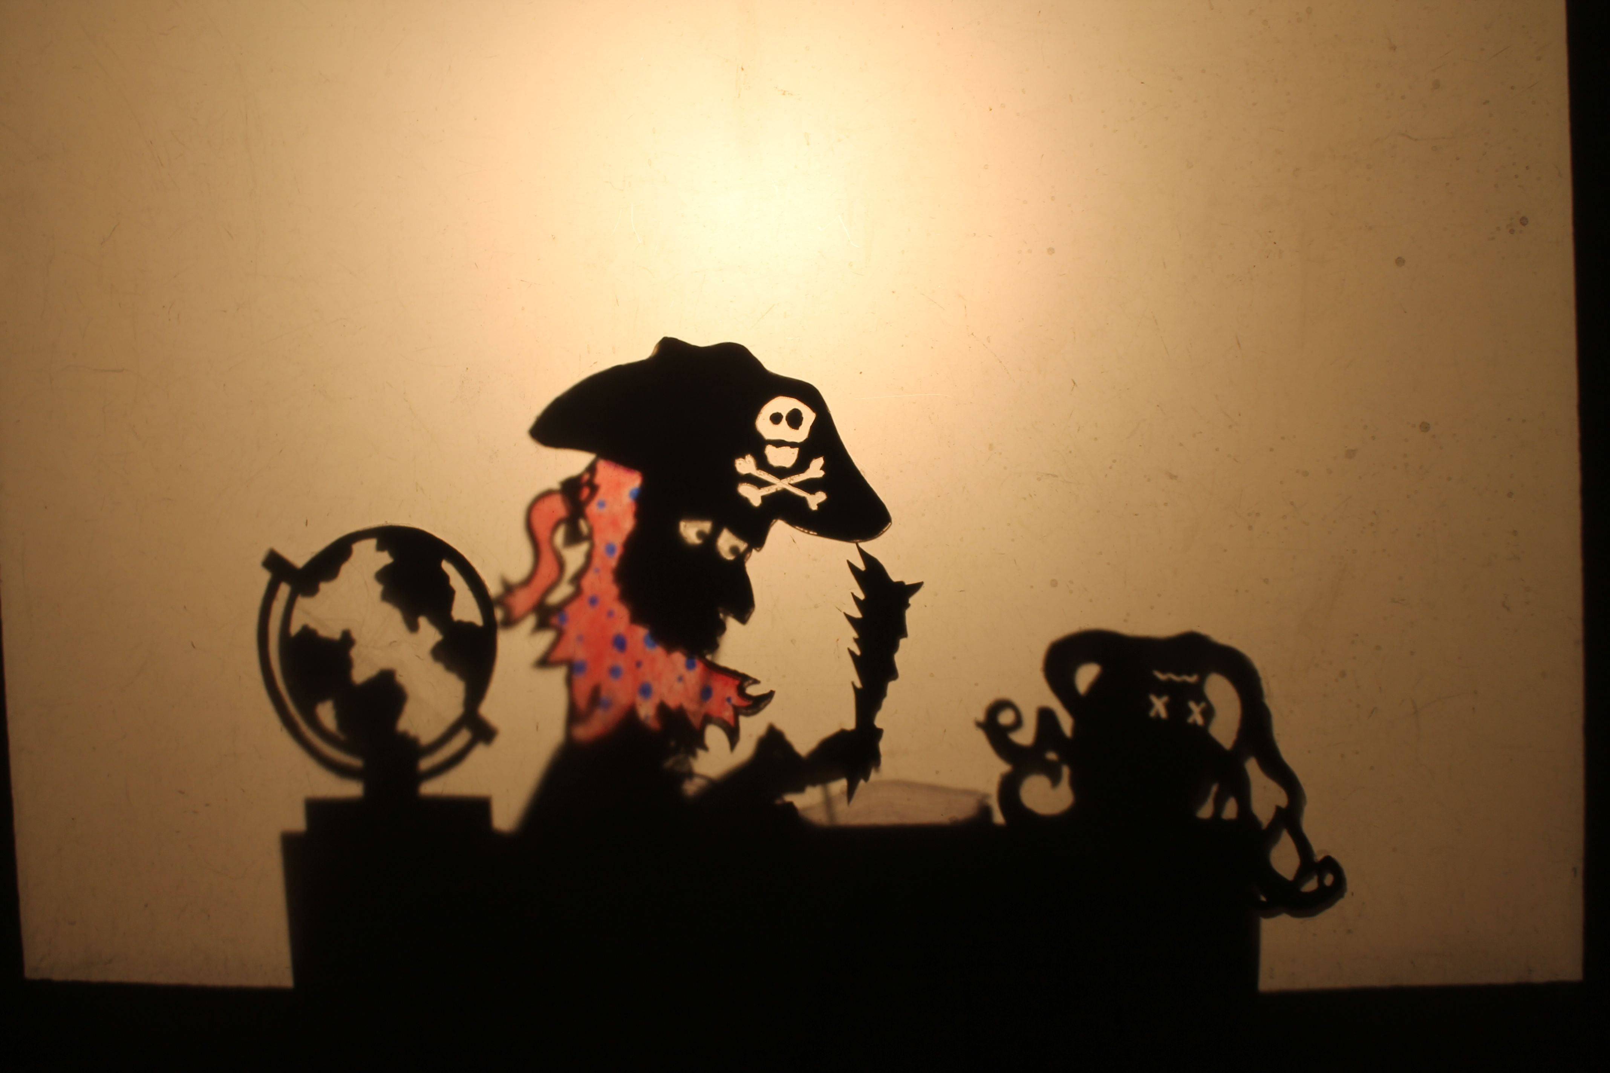

Contents

Artist Biography…………….…………………………… 3

The Performance: Walter Weirdbeard......……..3

A Word About Shadow Puppetry..........................3

Vocabulary ………………....……………………………...5

A Word About Frame Tales ………….……………..6

Pre-Performance Activities ………………….……..6

Lesson Plan: Poem-Writing ………………………..8

Suggested Reading/Viewing………..……..….…10

Contact Information ……………………....…….…10

-2-

Artist Biography

Matt Sandbank’s Shadow Factory is dedicated to creating and performing puppet shows
that promote literacy and excite young people about the power of words and the
imagination. Each of our programs features unique, handcrafted puppetry and ties in to
Language Arts curricular standards---as well as providing a rollicking good time for all!
Founder Matt Sandbank began building puppets as a middle school teacher. With just an
overhead projector and some scraps of cardboard, he put on puppet performances for his
students to help them master difficult lessons. Today, he hangs his hat in Austin, TX and
tours nationally, delighting audiences of all shapes and sizes.

The Performance: The Legend of Walter Weirdbeard

“Arrrrr!” is for Reading in this seafaring tale. The Legend of Walter Weirdbeard follows a crew of pirates on their search for buried treasure. After much tragedy and travail on the high seas, the pirates finally find their fabled treasure, only to discover that the chest holds no gold, no silver, and no jewels! The treasure chest is full, it turns out, of old, musty books. Mutiny and mayhem erupt on board the ship, and Captain Weirdbeard must think quickly to save his own life. He keeps his crew at bay by reading aloud the books from the treasure chest, leading the pirates on a journey into the imagination and revealing to them, one story after the next, how valuable a treasure books an be.

The Legend of Walter Weirdbeard lasts approximately 45 minutes, and it is appropriate for all elementary grade levels, K through 5th grade. Matt Sandbank’s Shadow Factory uses a combination of shadow puppets, and digital video projection for this program, and concludes the performance with a quick behind-the-scenes look at the puppets.

A Word About Shadow Puppetry

A traditional shadow puppet show can be defined generally as: a performance or ritual
in which two-dimensional figures are animated against a translucent screen, so that when
they are lit from behind, the audience views the moving shadows that those figures create.

-3-

The methods of animating the puppets, as well as the materials from which the puppets
are made, have changed throughout the history of the art form, and they often vary even
today according to the region or tradition from which the shadow puppet performance
arises. For example, traditional Chinese shadow puppets are operated by rods held
horizontally to the puppet, with the puppeteer standing behind the puppet, whereas
traditional Javanese puppets have a main vertical rod which runs usually the entire
length of the puppet’s body, and which the puppeteer controls from beneath.

We do not know for sure when shadow puppetry first emerged, but it is widely believed,
given certain myths and folktales about their beginnings, that shadow puppet plays have
been happening in China for at least 2,000 years. We also do not know the extent to
which shadow puppetry developed in several different Asian cultures independently, or
if it migrated from one area to another. We do know, however, that European interest in
shadow puppetry, which reached its height in the 1600s and 1700s, was very much
inspired by contact with Asian and Middle Eastern cultures.

The study of shadow puppetry may be used to enhance either a Social Studies or Science
curriculum. For Social Studies, the differences in shadow puppetry traditions in
different countries and cultures around the world makes for interesting comparison and
contrast projects. For Science, an investigation into shadow puppetry can help students
better understand terminology and concepts such as opaque, transparent, translucent,
etc. The internet is rife with photographs and videos of shadow puppet and shadow
puppetry performances from around the world to assist with these studies (though a
teacher previewing these videos is always recommended, as not all shadow
performances are meant for young audiences).

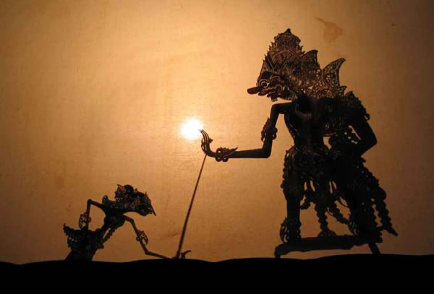

Indonesian (Javanese) Shadow Puppet

-4-

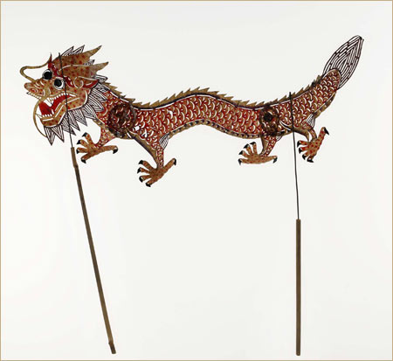

Chinese Shadow Puppet (these rods may be angled so that the puppeteer can stand directly behind the puppet during a performance.)

Vocabulary

The following list of vocabulary words and terms will relate to and enhance students’
understanding of The Legend of Walter Weirdbeard:

- Frame Tale
- Narrative Poem
- Genre
- Lyrics
- Characters/Characterization
- Rhythm
- Rhyme

-5-

A Word About Frame Tales

The Legend of Walter Weirdbeard uses a basic frame tale structure, with three shorter narratives (the stories that Weirdbeard reads to his crew) taking place—or being framed—within the main pirate narrative. The conceit of the frame tale has been used by writers and storytellers for hundreds of years, for a variety of reasons. In this case, the chief motivation for our using the frame tale is to better incorporate several different (and sometimes disparate) techniques, genres, characters, etc. in a single performance.

A specific understanding of the frame tale device is by no means necessary for a student’s enjoyment of The Legend of Walter Weirdbeard. It may, however, prove to be a useful jumping-off point for teachers to instruct students about several of the vocabulary terms listed above.

Pre-Performance Activities

The following is a list of suggested activities to do with your students prior to The Legend of Walter Weirdbeard in order to increase their familiarity with some of the themes of the performance.

Treasure Chest

One of the main themes of The Legend of Walter Weirdbeard is that of value. What does it mean for an object or an idea to be valuable? The following exercise gets students thinking in that direction.

Ask students to imagine that they are burying a treasure chest, only not a treasure chest filled with gold and silver. Ask them to write down phrases or a series of images that are the things that are most important to them. Make sure to instruct them to use vivid, clear imagery (ex. Rather than saying “my little sister,” say “my sister Ruth with her crazy giggle”). If students generate enough ideas, the resulting list will form a simple poem.

For a cross-curricular approach, have students write down their phrases/images on slips
of paper, then place the pieces of paper in a shoebox. Hide the shoebox somewhere on the playground, and create a treasure map to help students find it. Skills that students

-6-

have developed in map-reading and/or coordinate planes may be used to assist them in finding the treasure, thereby incorporating Social Studies and Math learning objectives.

Mysterious Pen-Pals

Frame tales also create a quick change in perspective for the reader/viewer. Moreover, in The Legend of Walter Weirdbeard, the pirates begin to develop a new perspective on their lives, thanks to the stories they hear. The goal of this activity is for the student to choose an object in his or her desk and write a letter from that object’s perspective.

Begin by explaining the concept of perspective, emphasizing that a perspective change makes the reader look at something from a different angle. Instruct students to choose an object from their desk. They are then to write a letter to you, the teacher, using the voice and perspective of that object. What would a pencil’s day in class be like? What would a science textbook observe/talk like?

Here’s the catch: in the letter, the students are not to say directly what the object is, but only to give clues/hints based on that object’s perspective/way of viewing the world.. After every student has written a letter to you, collect them, and at a convenient time, read some of the letters aloud, allowing students to attempt to guess what object wrote that letter.

Pitching a Movie

The Legend of Walter Weirdbeard also experiments with several genres. A writer using frame tales can switch back and forth between genres as often as he or she likes. The following is a group activity that allows students to get some practice playing with the idea of genre.

Begin by explaining or reviewing the concept of genre. Then make a list of several movie genres. If students have difficulty, prompt them towards some of the major categories, such as romance, action/adventure, horror, and detective/mystery. Then make a list of famous fairy tales.

Next, give them the following scenario. You, the teacher, are a Hollywood producer, looking to make your next summer smash hit. The students are to get into groups of two
or three and write up a sales pitch/movie synopsis, using one of the genres and one of the
fairy tales. Rumpelstiltskin as a detective movie. Cinderella as an action movie. And so
on.

-7-

These should be short, one-paragraph synopses, but they should use strong, detailed language that make the paragraph fit in with the genre. Stress adjectives and vivid imagery with this activity. It may be useful to have students watch several movie trailers from different genres before attempting this exercise.

To enhance the mood of this exercise, you can even download music from iTunes (search for “movie trailer music”) for students to play when they read off their pitch to the producer. You can also have the class vote on which sales pitch to turn into a movie, and discuss what made it a good pitch/what makes one genre distinct from the next.

Lesson Plan: Poetry Writing

Matt distinguishes between the framed tales and the framing tale in The Legend of Walter Weirdbeard by depicting the framed tales with shadow puppets, as well as being depicted in verse. Matt uses the following lesson plan most often to teach poetry-writing workshops as a follow-up to his performances. The guiding principle behind the lesson is that the cornerstone to effective writing (poetic and otherwise) is the generation and use of striking, vivid imagery. The lesson plan is written to third grade learning standards, but each elementary grade level has a corresponding standard, so the plan may be easily adapted for a variety of age and ability ranges.

Poetry Writing Workshop: Guiding Images and Word Arrangement

Matt Sandbank

Grade Level: All Elementary Grades

Subject: Language Arts

Lesson Time: 55 minutes

Content Standards: 3 – Writing
8- Literature
Grade Level Expectations:
TEKS 3rd Grade Language Arts Standards (3rd grade given as example, but lesson may be modified to fit lower and upper grade levels, as well. Common Core Standards may also be applied):

(17.A) plan a first draft by selecting a genre appropriate for conveying the intended meaning to an audience and generating ideas through a range of strategies (e.g., brainstorming, graphic organizers, logs, journals);

(18.B) write poems that convey sensory details using the conventions of poetry (e.g., rhyme, meter, patterns of verse).

-8-

Lesson Introduction (5 minutes):

Presenter will: 1) Engage students’ interest by reciting a poem and performing a shadow-puppet skit as an accompanying illustration. 2) Ask follow-up questions to check for comprehension and for student awareness of literary devices.

Students will: Demonstrate comprehension of poem and understanding of literary devices by answering the presenter’s questions.

Guided Practice (15 minutes):

Presenter will: Demonstrate a method of drafting a poem by 1) soliciting student examples of imagery, 2) choosing one student example of an image and soliciting student examples of other words related to that image, 3) arranging the words on the word list into simple lines of verse, and 4) emphasizing for students the use of rhythm, onomatopoeia, alliteration, and other literary devices in these lines.

Students will: 1) Offer examples of imagery. 2) Contribute words to the extended list.

Independent Practice (30 minutes):

Presenter will: 1) Instruct students to imitate the earlier process by focusing on a single image, generating a word list around that image, and arranging those generated words into lines of poetry. 2) Circulate the room, offering encouragement and advice to students, and reading aloud student lines which exemplify good use of poetic devices.

Students will: 1) Choose an image. 2) Generate a word list. 3) Write lines of poetry.

Closure (5 minutes):

Presenter will: Ask for student volunteers to read poems, continuing to point out good use of literary devices.

Students will: Read poems to class on a volunteer basis.

Extension (30 to 60 minutes)

Presenter will: Demonstrate a method for creating shadow puppets using cardstock, flexistraws, scotch tape, and metal brads. Emphasize certain key concepts of shadow puppetry, such as simplicity of design, kinesthetic awareness, and incidental vs. controlled movement.

Students will: Create shadow puppets to illustrate their poem.

-9-

Suggested Reading/Viewing

Excerpts from the following works of literature and film can be used to demonstrate the concept of the frame tale:

- One Thousand and One Nights (or Arabian Nights), a collection of folk tales originating from the Middle East and South Asia
- The Princess Bride, the film by Rob Reiner
- The Neverending Story, a film by Wolfgang Peterson

The following study questions may be asked in reference to any of these stories/films:

- How is the genre of the framed (smaller) story different than the genre of the framing (larger)story?
- How are the characters in the framed story similar or different than the characters in the framing story.
- What does the framed story tell you about the reader (Weirdbeard) of the framing story?
- How does framing a story affect the pace of the story? Does it make the story more or less exciting to you?
- Do you relate more to the characters in the framed story or the framing story? Why?

Contact Information

Matt Sandbank’s Shadow Factory welcomes any questions or comments regarding this study guide, poetry or puppetry in general, or anything else that might happen to cross an educator’s mind. For more information, see our website: www.sandbankshadowfactory.com. Feel free to contact us at:

Phone: (505) 816-8379
Email: sandbankshadowfactory@gmail.com

-10-

